Group Name python GROUP

Project Title CALCULATOR APP

IJENMOR ALEX MICHAEL

BHU/22/04/09/0102

SOLOMON EZIJOTA ENITIE

BHU/22/04/09/0018

Project Description and Screenshots

It is a calculator app which solves simple mathematical problems like addition, subtraction, multiplication and division. The app was created using java for it.

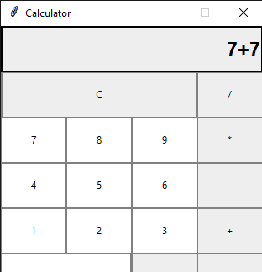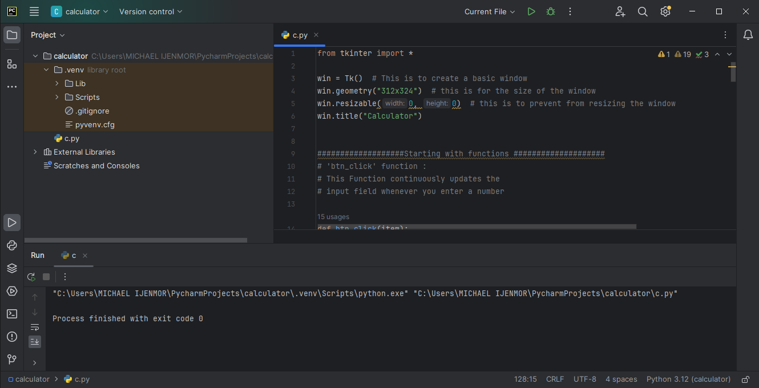

IJENMOR ALEX MICHAEL

BHU/22/04/09/0102

He is the group leader and head developer of the project, he started with research and started with work on the project, we used his pc for the project which led to the actualization of the project which also enable the completion of the project.

SOLOMON EZIJOTA ENITIE

BHU/22/04/09/0018

He also helped with research and development of the project and also bringing critical knowledge of the project which help us to further the project. He was also part of the development and research party of the group who has a broad knowledge of the project and was instrumental in the completion.

